Solids with Curved Surfaces

Definition
# Source: AI Source: Provided by: [Data Path: Persons Table -> ID Column: 1, Name_En Column: Motasem Essam] -> From: [ChatGPT] on [7/25/2026]
Solids with curved surfaces are three-dimensional geometric objects that have at least one boundary surface that is curved rather than entirely flat.
Unlike polyhedra, which are bounded entirely by flat polygonal faces, these solids have curved surfaces, circular boundaries, or both. Some have flat faces as well as curved surfaces.
Examples include the sphere, cylinder, cone, and hemisphere.
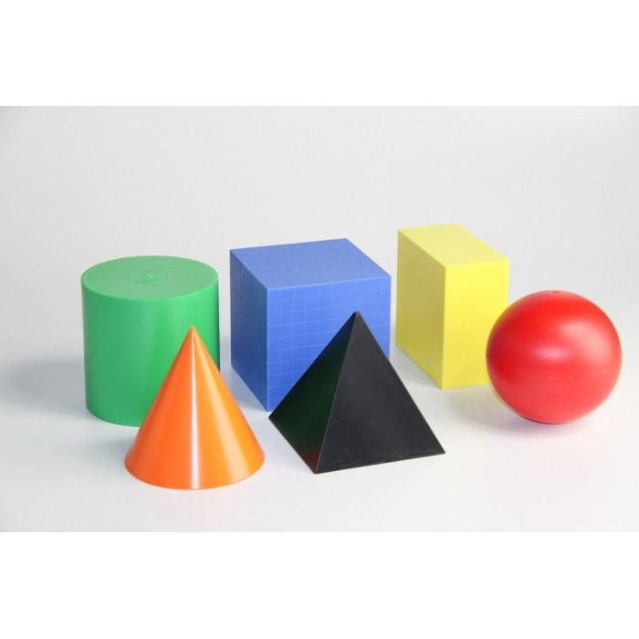

Simple definition
# Source: AI Source: Provided by: [Data Path: Persons Table -> ID Column: 1, Name_En Column: Motasem Essam] -> From: [ChatGPT] on [7/25/2026]
A solid with a curved surface is a 3D shape that has at least one rounded or curved outer surface.
Examples:
- Sphere: a completely curved surface, like a ball.
- Cylinder: a curved side and two flat circular bases, like a can.
- Cone: a curved side, one flat circular base, and one apex, like an ice-cream cone.
- Hemisphere: half of a sphere, with a curved surface and one flat circular face.

Key characteristics
# Source: AI Source: Provided by: [Data Path: Persons Table -> ID Column: 1, Name_En Column: Motasem Essam] -> From: [ChatGPT] on [7/25/2026]
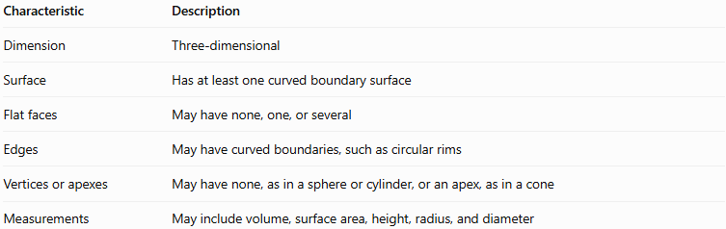
Characteristic | Description
Dimension | Three-dimensional
Surface | Has at least one curved boundary surface
Flat faces | May have none, one, or several
Edges | May have curved boundaries, such as circular rims
Vertices or apexes | May have none, as in a sphere or cylinder, or an apex, as in a cone
Measurements | May include volume, surface area, height, radius, and diameter
A curved surface is a two-dimensional part of a solid's boundary. A curved boundary edge, such as the circular rim of a cylinder, is a one-dimensional curve.

Main types of solids with curved surfaces

1. Sphere
# Source: AI Source: Provided by: [Data Path: Persons Table -> ID Column: 1, Name_En Column: Motasem Essam] -> From: [ChatGPT] on [7/25/2026]
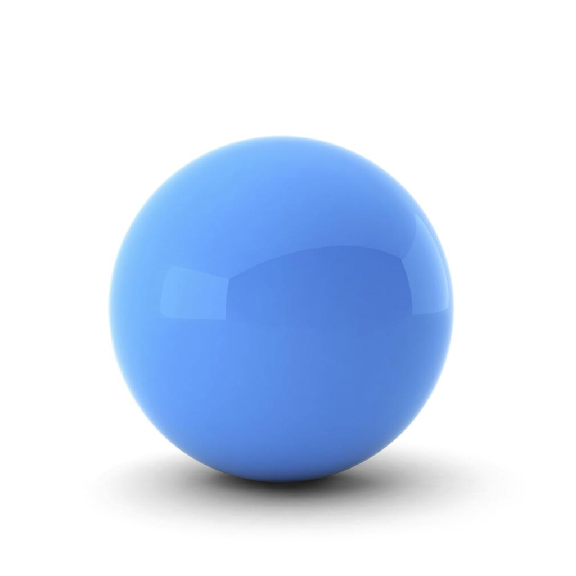
A sphere is a solid whose boundary consists entirely of points at a fixed distance from its center.
- One continuous curved outer surface.
- No flat faces, straight edges, or vertices.
- Every point on its surface is the same distance $r$ from the center.
Formulas:
- Surface area: $S=4πr^{2}$
- Volume: $V=\frac{4}{3}πr^{3}$
- Diameter: $d=2r$
Examples: a ball, a spherical bead, and an idealized planet.

2. Cylinder
# Source: AI Source: Provided by: [Data Path: Persons Table -> ID Column: 1, Name_En Column: Motasem Essam] -> From: [ChatGPT] on [7/25/2026]
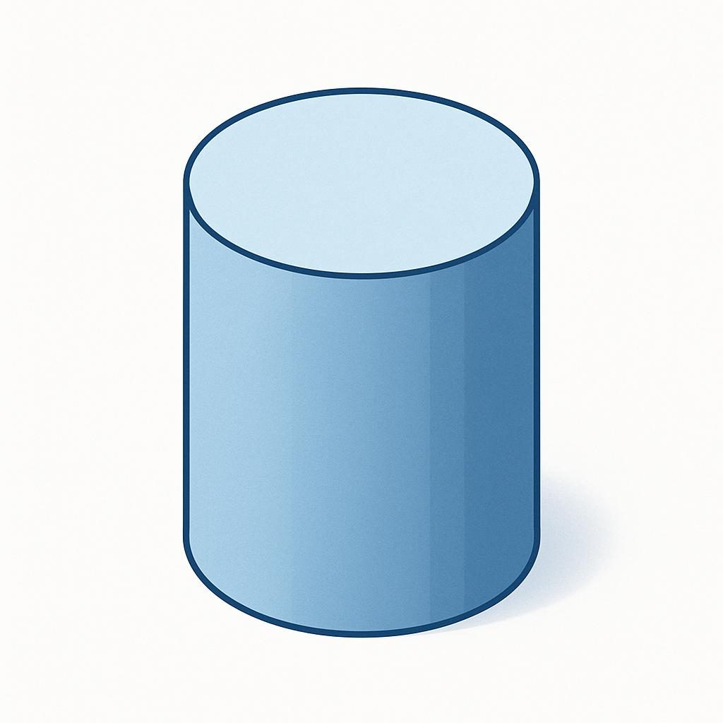
A cylinder is a solid with two parallel, congruent circular bases connected by a curved lateral surface.
- Two flat circular bases.
- One curved lateral surface.
- Two circular boundary edges.
- No vertices in a right circular cylinder.
Formulas for a right circular cylinder:
- Curved surface area: $S_{c}=2πrh$
- Total surface area: $S=2πrh+2πr^{2}$
- Volume: $V=πr^{2}h$
Here, $r$ is the base radius and $h$ is the perpendicular height.
Examples: a can, a pipe (idealized), and a cylindrical container.

3. Cone
# Source: AI Source: Provided by: [Data Path: Persons Table -> ID Column: 1, Name_En Column: Motasem Essam] -> From: [ChatGPT] on [7/25/2026]
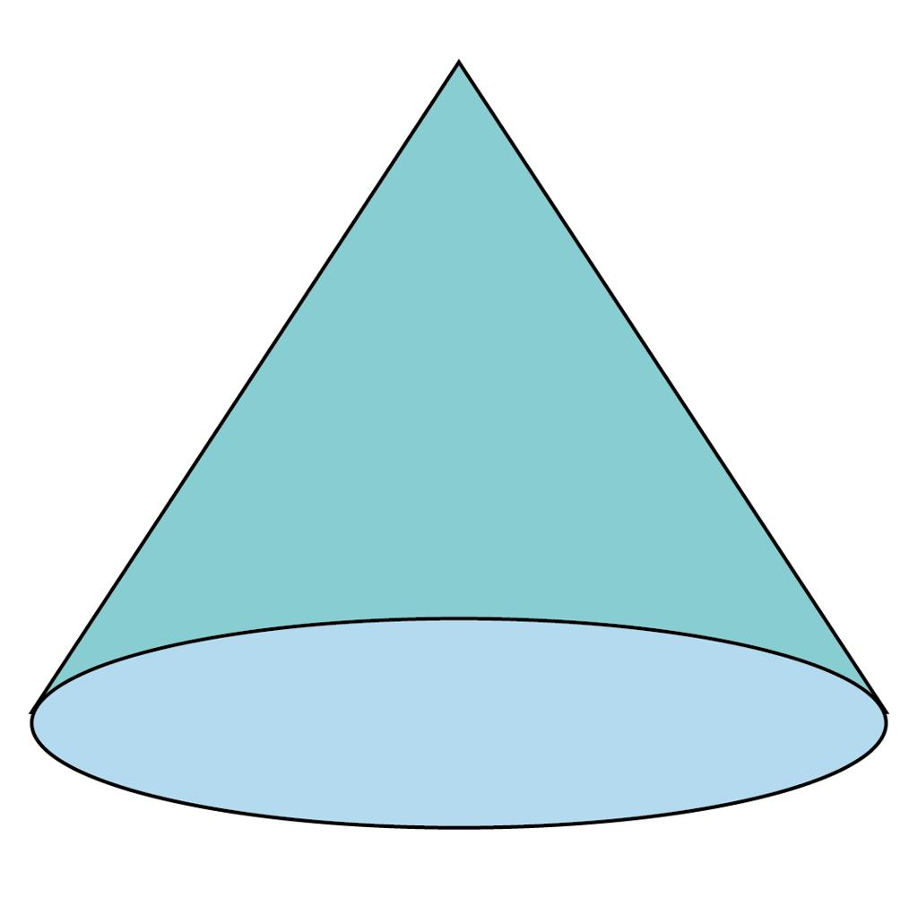
A cone is a solid with a circular base and a curved lateral surface that narrows to a single point called the apex.
- One flat circular base.
- One curved lateral surface.
- One circular boundary edge.
- One apex.
Formulas for a right circular cone:
- Curved surface area: $S_{c}=πrl$
- Total surface area: $S=πrl+πr^{2}$
- Volume: $V=\frac{1}{3}πr^{2}h$
Here, $r$ is the base radius, $h$ is the perpendicular height, and $l$ is the slant height.
For a right circular cone:
$$l=\sqrt{r^{2}+h^{2}}$$
Examples: an ice-cream cone, a traffic cone, and a conical funnel.

4. Hemisphere
# Source: AI Source: Provided by: [Data Path: Persons Table -> ID Column: 1, Name_En Column: Motasem Essam] -> From: [ChatGPT] on [7/25/2026]
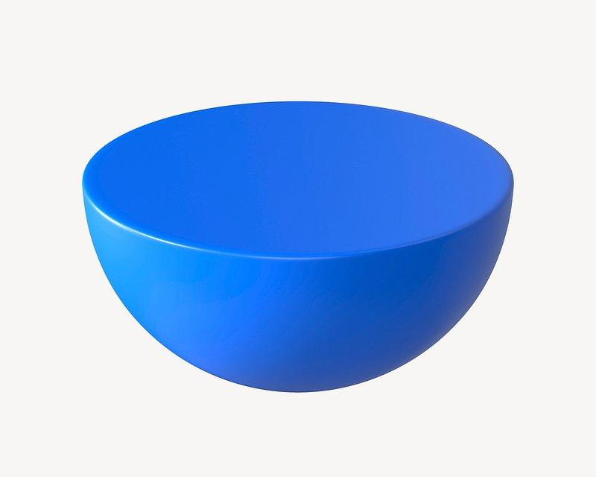
A hemisphere is half of a sphere divided by a plane passing through its center.
- One curved hemispherical surface.
- One flat circular base.
- One circular boundary edge.
- No vertices.
Formulas:
- Curved surface area: $S_{c}=2πr^{2}$
- Total surface area, including the base: $S=3πr^{2}$
- Volume: $V=\frac{2}{3}πr^{3}$
Examples: a hemispherical bowl (idealized), a dome, and half of a spherical model.

5. Truncated cone (conical frustum)
# Source: AI Source: Provided by: [Data Path: Persons Table -> ID Column: 1, Name_En Column: Motasem Essam] -> From: [ChatGPT] on [7/25/2026]
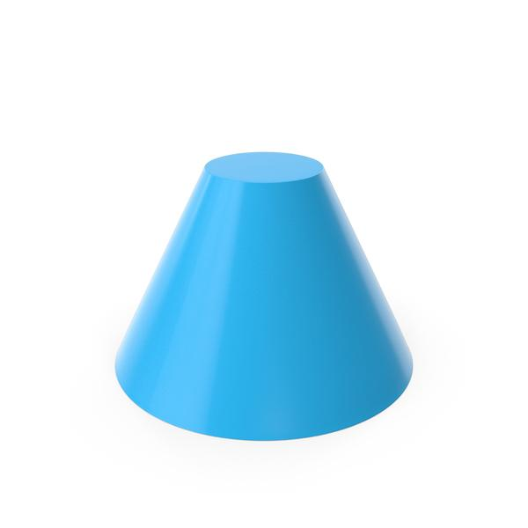
A conical frustum is the portion of a cone remaining after its top is cut off by a plane parallel to its base.
- Two parallel circular bases of different radii.
- One curved lateral surface.
- Two circular boundary edges.
- No apex on the remaining solid.
Formulas for a right circular frustum:
- Curved surface area: $S_{c}=π\left(R+r\right)l$
- Total surface area: $S=π\left(R+r\right)l+πR^{2}+πr^{2}$
- Volume: $V=\frac{1}{3}πh\left(R^{2}+Rr+r^{2}\right)$
Here, $R$ and $r$ are the larger and smaller base radii, $h$ is the perpendicular height, and $l$ is the slant height.
Examples: a lampshade with sloping sides, a tapered cup, and a truncated funnel.

6. Ellipsoid
# Source: AI Source: Provided by: [Data Path: Persons Table -> ID Column: 1, Name_En Column: Motasem Essam] -> From: [ChatGPT] on [7/25/2026]
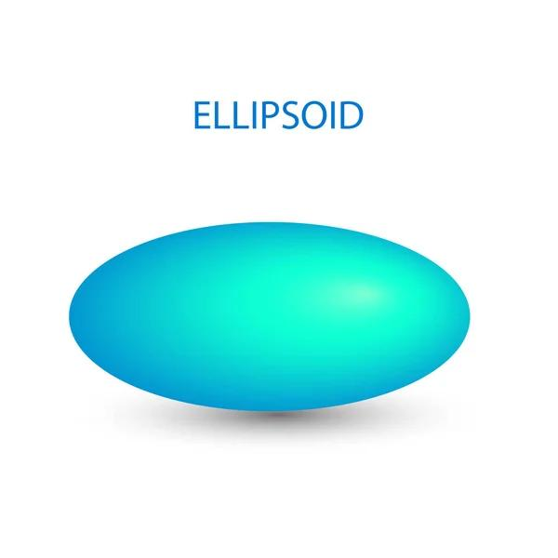
An ellipsoid is a closed solid bounded by a smooth oval-shaped surface. It generalizes a sphere by allowing different dimensions along three perpendicular axes.
- One continuous curved boundary surface.
- No flat faces, edges, or vertices.
- May be elongated, flattened, or spherical.
Its boundary can be represented by:
$$\frac{x^{2}}{a^{2}}+\frac{y^{2}}{b^{2}}+\frac{z^{2}}{c^{2}}=1$$
Here, $a$, $b$, and $c$ are the three semi-axis lengths.
Its volume is:
$$V=\frac{4}{3}πabc$$
Examples: an idealized egg-shaped or oval object, and mathematical models of some planets. An actual egg is generally not a perfect ellipsoid.

7 Torus
# Source: AI Source: Provided by: [Data Path: Persons Table -> ID Column: 1, Name_En Column: Motasem Essam] -> From: [ChatGPT] on [7/25/2026]
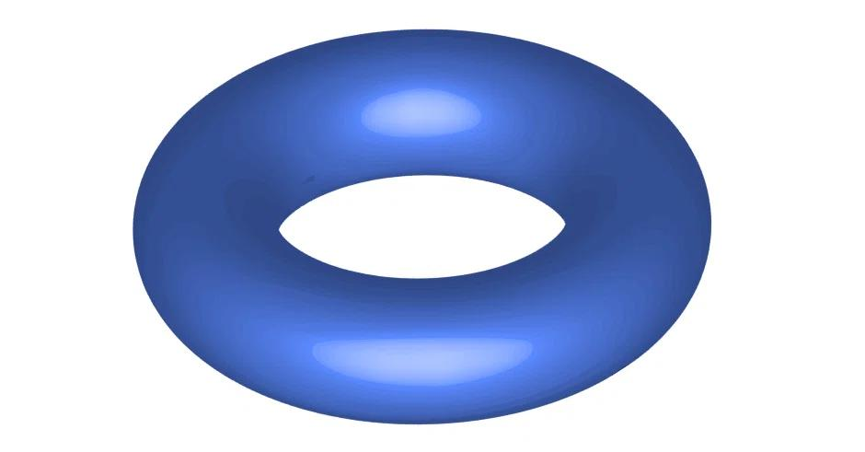
A torus is a ring-shaped solid formed by revolving a circle around an axis in the same plane that does not intersect the circle.
- Curved outer and inner surfaces.
- No flat faces in the standard ring-shaped form.
- No ordinary edges or vertices.
- Has a central hole.
For a standard ring torus:
$$V=2π^{2}Rr^{2}$$
$$S=4π^{2}Rr$$
Here, $R$ is the distance from the torus center to the center of the tube, and $r$ is the tube radius, with $R>r$.
Example: a doughnut-shaped ring or an idealized inflatable ring.

Comparison table
# Source: AI Source: Provided by: [Data Path: Persons Table -> ID Column: 1, Name_En Column: Motasem Essam] -> From: [ChatGPT] on [7/25/2026]
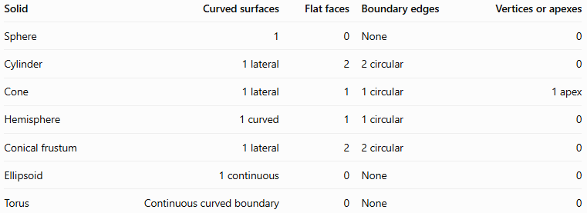
Solid | Curved surfaces | Flat faces | Boundary edges | Vertices or apexes
Sphere | 1 | 0 | None | 0
Cylinder | 1 lateral | 2 | 2 circular | 0
Cone | 1 lateral | 1 | 1 circular | 1 apex
Hemisphere | 1 curved | 1 | 1 circular | 0
Conical frustum | 1 lateral | 2 | 2 circular | 0
Ellipsoid | 1 continuous | 0 | None | 0
Torus | Continuous curved boundary | 0 | None | 0
The table describes the standard idealized forms. Some textbooks use different conventions when counting surfaces or describing boundary parts.

Geometric representations and mathematical properties
# Source: AI Source: Provided by: [Data Path: Persons Table -> ID Column: 1, Name_En Column: Motasem Essam] -> From: [ChatGPT] on [7/25/2026]
Solids with curved surfaces can be studied using three main types of measurements.
Radius and height
The radius measures the distance from the center of a circular base to its boundary. The perpendicular height measures the distance between parallel bases, or from the apex to the base plane in a right cone.
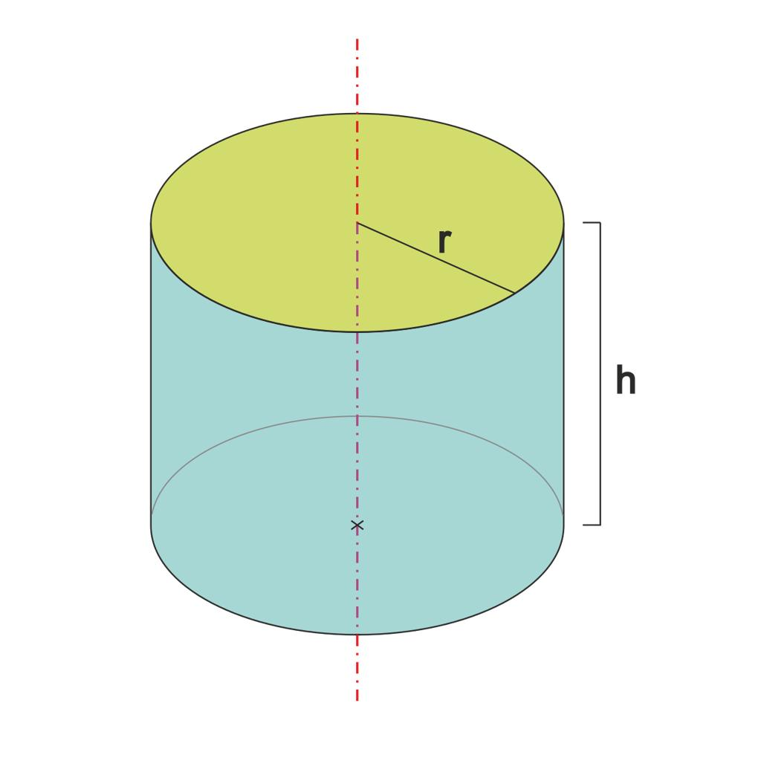
Slant height
The slant height is measured along the sloping side of a cone or frustum. For a right cone, $l^{2}=r^{2}+h^{2}$.
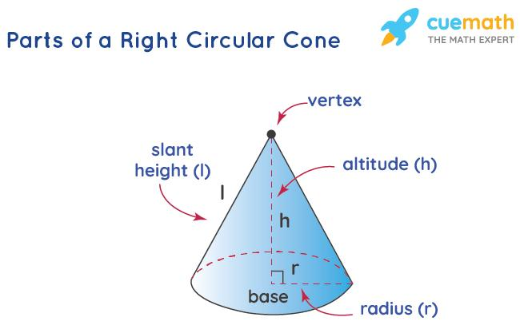
Radius and diameter
In a sphere, the diameter passes through the center and joins two opposite points on the surface. Its length is twice the radius: $d=2r$.
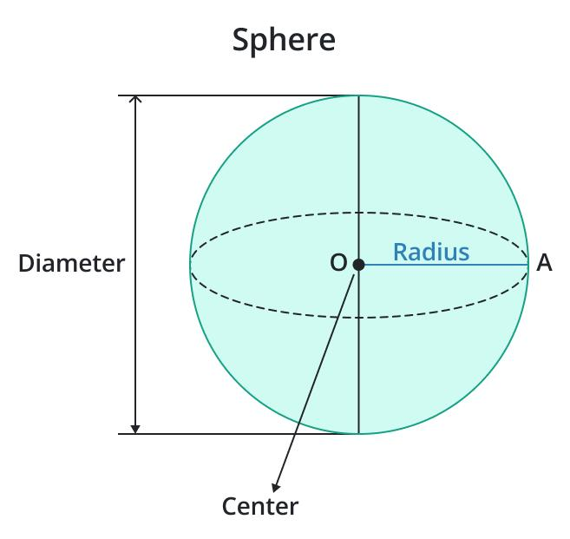

Worked examples
# Source: AI Source: Provided by: [Data Path: Persons Table -> ID Column: 1, Name_En Column: Motasem Essam] -> From: [ChatGPT] on [7/25/2026]
Example 1: Volume of a cylinder
A cylinder has radius $r=3\text{ cm}$ and height $h=8\text{ cm}$. Find its volume.
Using the cylinder volume formula:
$$V=πr^{2}h$$
Substitute the measurements:
$$V=π{\left(3\right)}^{2}\left(8\right)=72π$$
Answer: $72π{\text{ cm}}^{3}$, approximately $226.2{\text{ cm}}^{3}$.
Example 2: Total surface area of a sphere
A sphere has radius $r=5\text{ cm}$. Find its surface area.
$$S=4πr^{2}$$
$$S=4π{\left(5\right)}^{2}=100π$$
Answer: $100π{\text{ cm}}^{2}$, approximately $314.16{\text{ cm}}^{2}$.
Example 3: Volume of a cone
A right circular cone has radius $r=4\text{ cm}$ and perpendicular height $h=9\text{ cm}$. Find its volume.
$$V=\frac{1}{3}πr^{2}h$$
$$V=\frac{1}{3}π{\left(4\right)}^{2}\left(9\right)=48π$$
Answer: $48π{\text{ cm}}^{3}$, approximately $150.8{\text{ cm}}^{3}$.
Example 4: Volume of a hemisphere
A hemisphere has radius $r=6\text{ cm}$. Find its volume.
$$V=\frac{2}{3}πr^{3}$$
$$V=\frac{2}{3}π{\left(6\right)}^{3}=144π$$
Answer: $144π{\text{ cm}}^{3}$, approximately $452.4{\text{ cm}}^{3}$.

Comparison with polyhedra
# Source: AI Source: Provided by: [Data Path: Persons Table -> ID Column: 1, Name_En Column: Motasem Essam] -> From: [ChatGPT] on [7/25/2026]
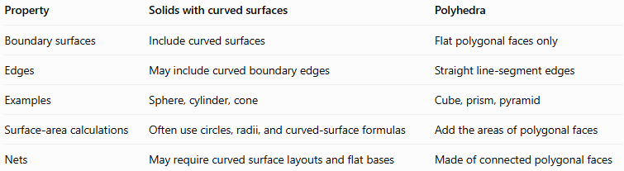
Property | Solids with curved surfaces | Polyhedra
Boundary surfaces | Include curved surfaces | Flat polygonal faces only
Edges | May include curved boundary edges | Straight line-segment edges
Examples | Sphere, cylinder, cone | Cube, prism, pyramid
Surface-area calculations | Often use circles, radii, and curved-surface formulas | Add the areas of polygonal faces
Nets | May require curved surface layouts and flat bases | Made of connected polygonal faces
A solid can also combine both types of boundary: for example, a cylinder has a curved lateral surface and flat circular bases.

Applications in everyday life
# Source: AI Source: Provided by: [Data Path: Persons Table -> ID Column: 1, Name_En Column: Motasem Essam] -> From: [ChatGPT] on [7/25/2026]
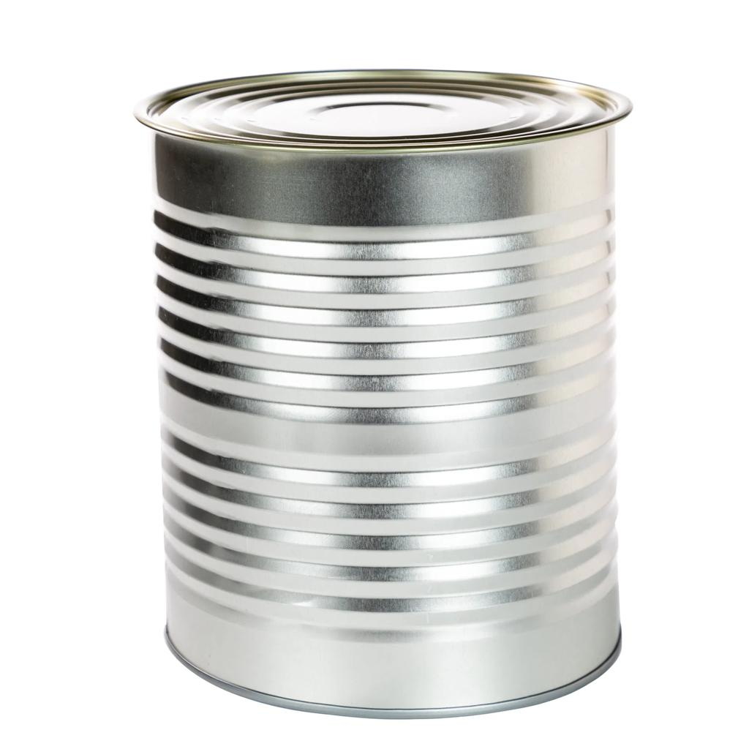
Cylinder
Cans, tanks, pipes, and containers.
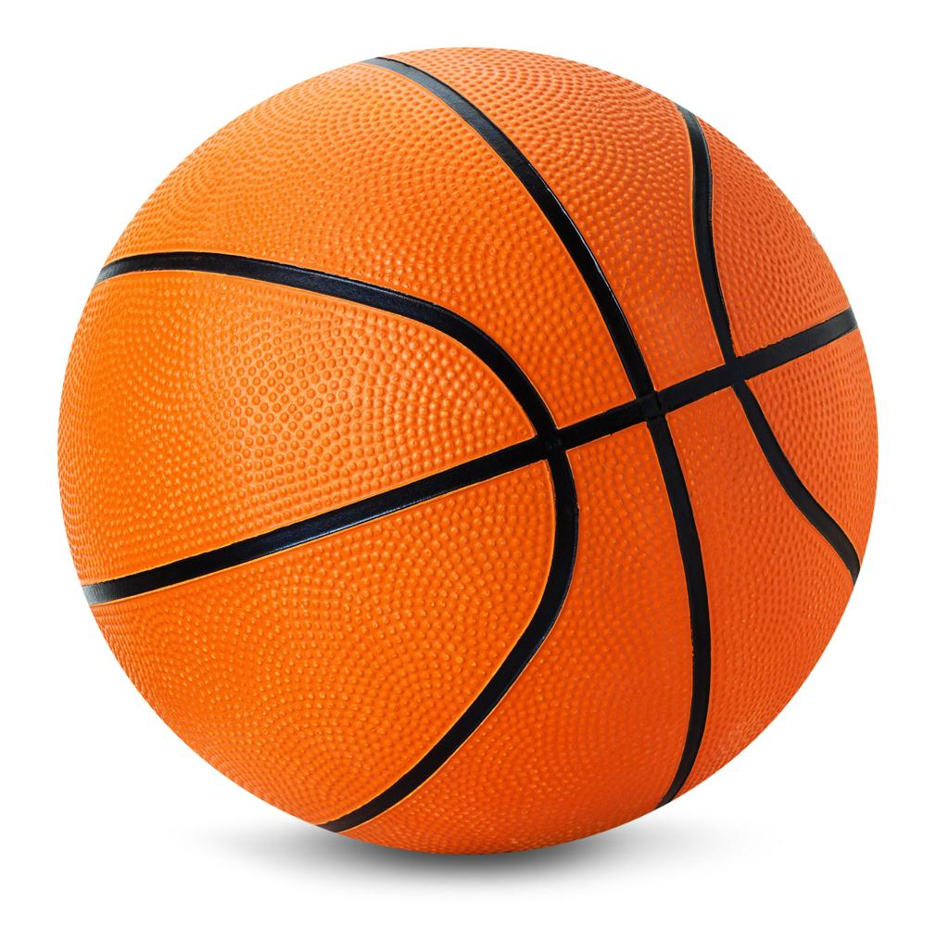
Sphere
Balls, spherical bearings, and scientific models.
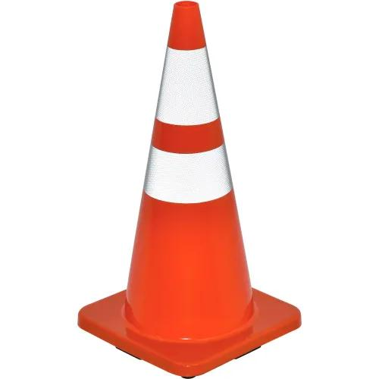
Cone
Traffic markers, funnels, and conical roofs.
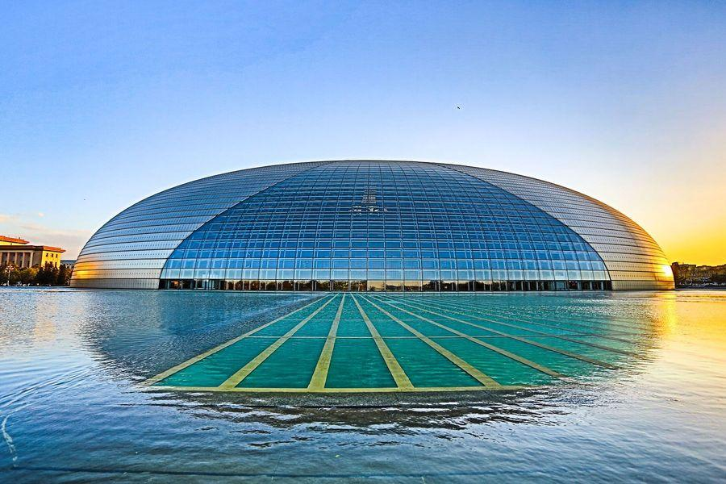
Hemisphere
Domes, bowl-shaped designs, and observatory structures.
These shapes are important in architecture, engineering, manufacturing, packaging, and mathematical modeling because their surface areas and volumes help determine material requirements, capacity, and dimensions.

Key points
# Source: AI Source: Provided by: [Data Path: Persons Table -> ID Column: 1, Name_En Column: Motasem Essam] -> From: [ChatGPT] on [7/25/2026]
- A solid with a curved surface has at least one curved portion of its boundary.
- A sphere has a completely curved boundary and no flat faces.
- A cylinder has two circular bases and a curved lateral surface.
- A cone has a circular base, a curved lateral surface, and an apex.
- A hemisphere has one curved surface and one flat circular base.
- A conical frustum has two circular bases and a curved lateral surface.
- An ellipsoid and a torus are additional examples of solids with curved boundaries.
- Surface area measures the boundary's area, while volume measures the space enclosed by the solid.

Conclusion
# Source: AI Source: Provided by: [Data Path: Persons Table -> ID Column: 1, Name_En Column: Motasem Essam] -> From: [ChatGPT] on [7/25/2026]
Solids with curved surfaces form an important category of three-dimensional geometry. Their distinguishing feature is a curved boundary, which may occur alone or together with flat faces. Understanding their shapes, boundaries, and formulas provides the foundation for calculating surface area and volume and distinguishing them from polyhedra.

